CS 255 System Design Document Template

Charles Roaf
08/16/2026

UML Diagrams

UML Use Case Diagram

The use case diagram illustrates the interactions between users and the DriverPass system. It identifies the major user groups and system functions required to support driver education, lesson scheduling, and administrative operations.
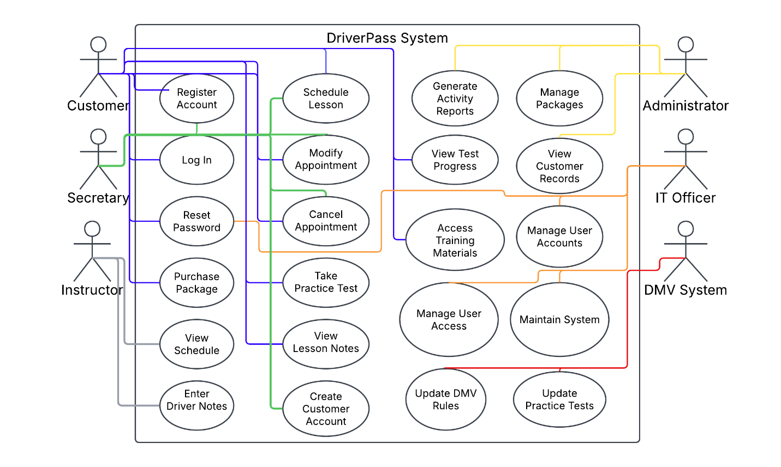
Figure 1. DriverPass Use Case Diagram

UML Activity Diagrams

The following activity diagrams illustrate the step-by-step workflows associated with lesson scheduling and online practice testing.
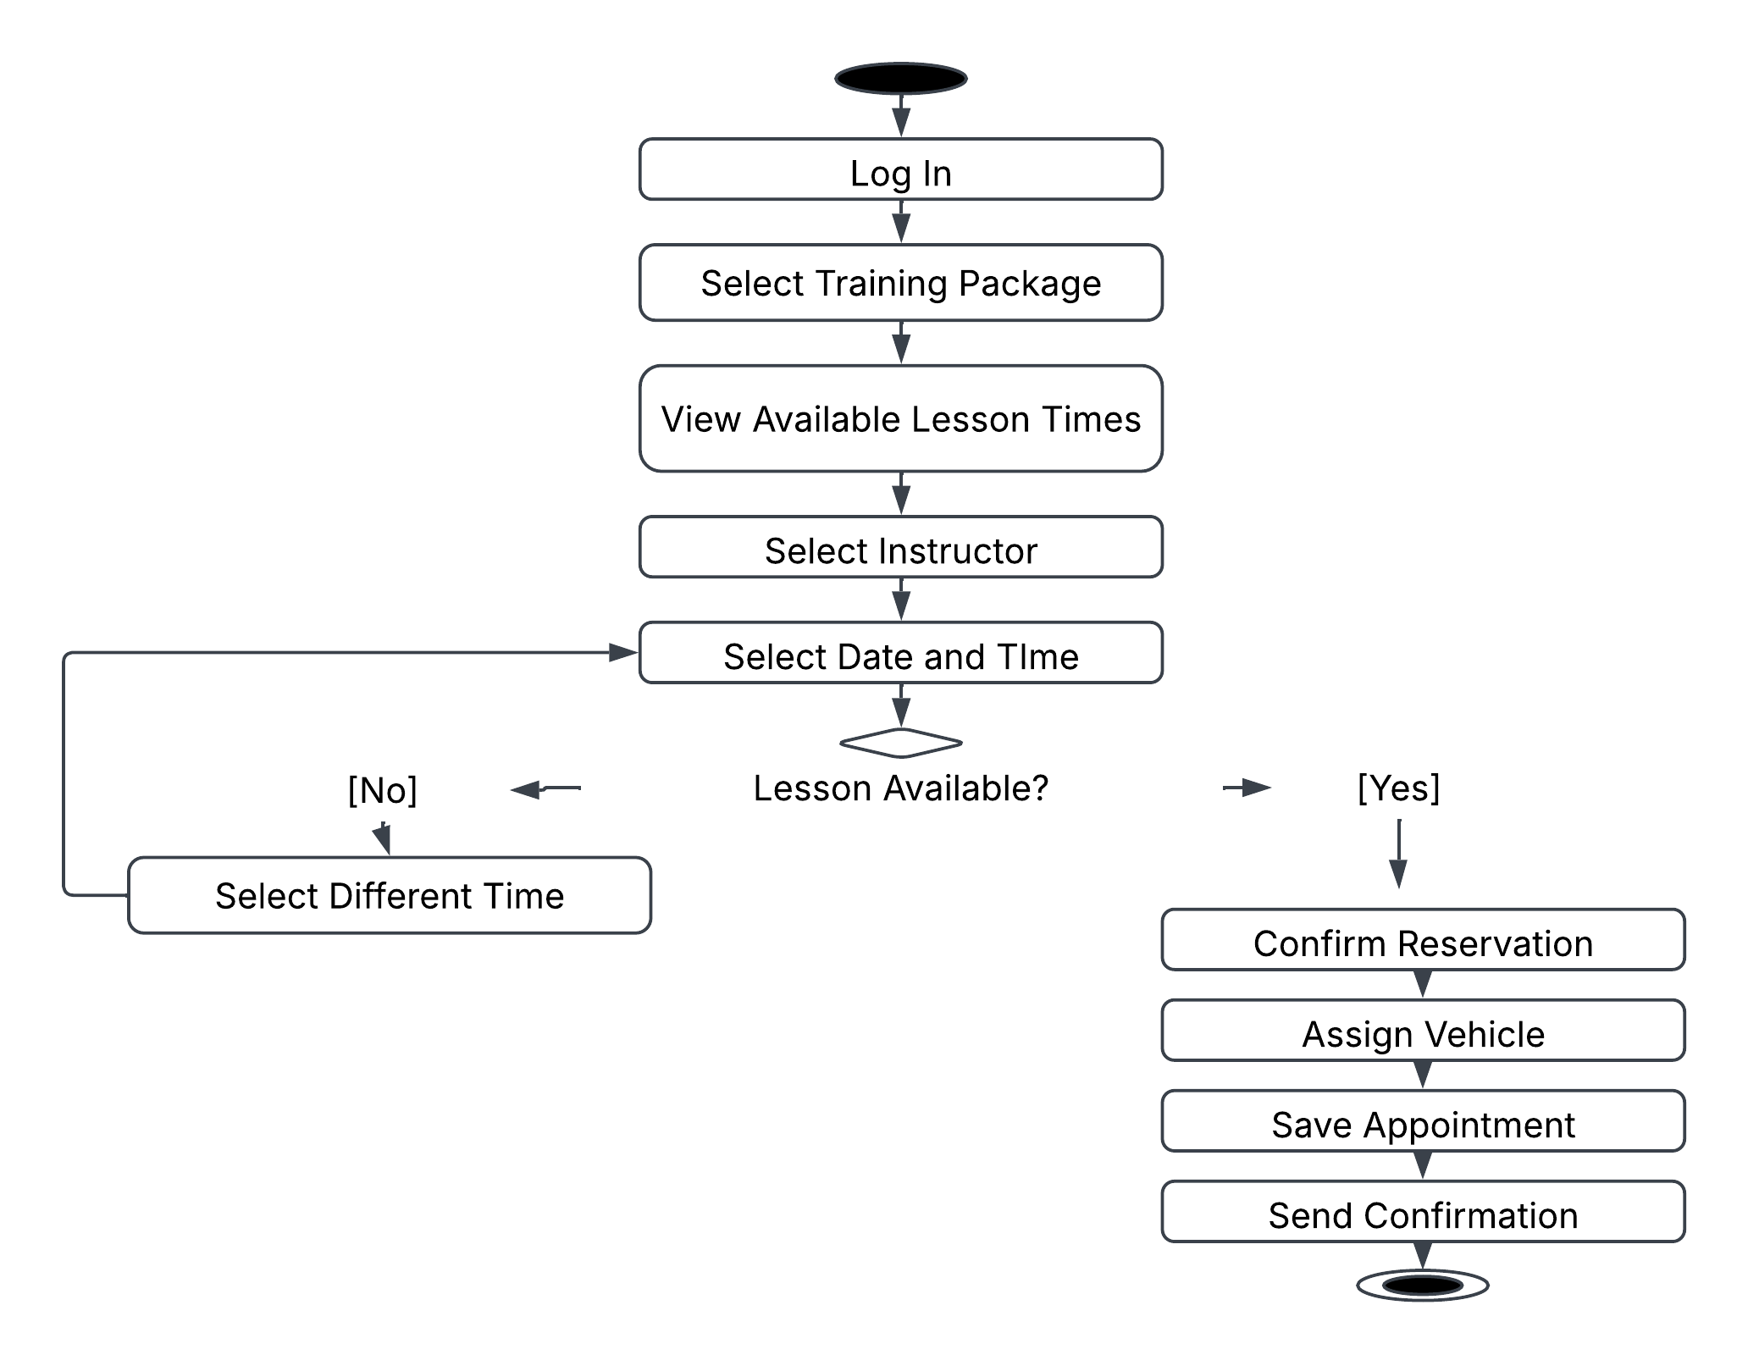
Figure 2. Schedule Lesson Activity Diagram

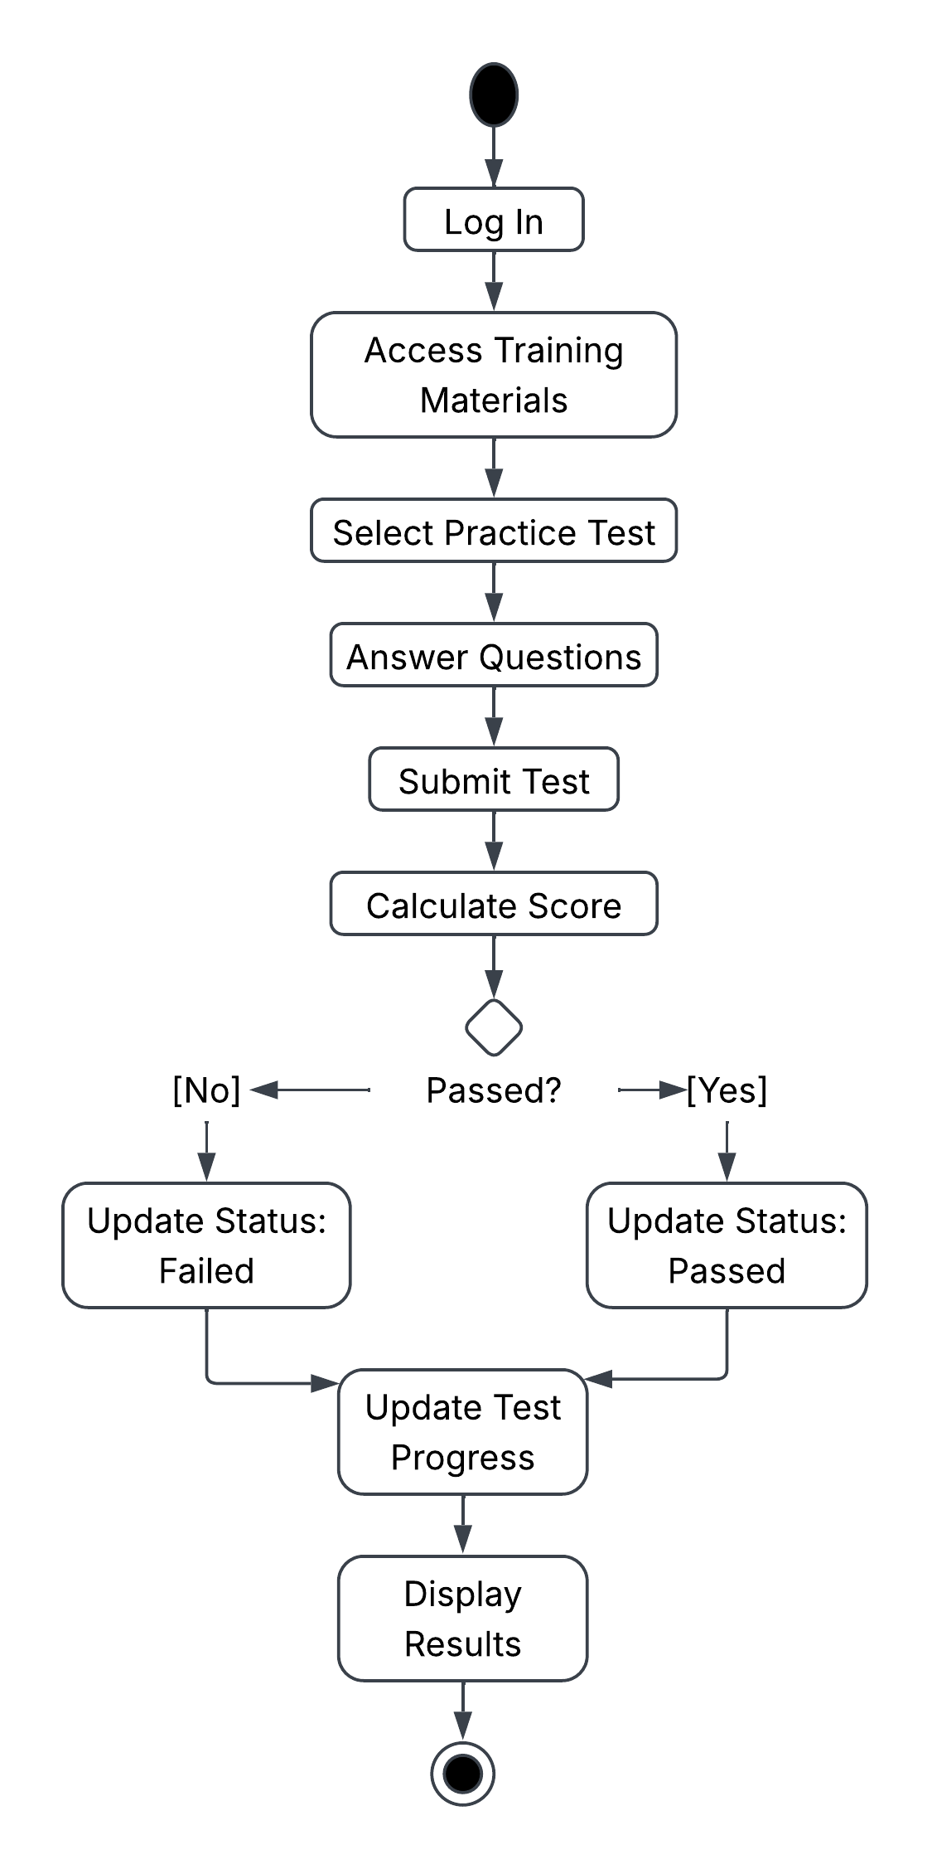
Figure 3. Take Practice Test Activity Diagram

UML Sequence Diagram

The sequence diagram demonstrates the interactions among system components during the lesson scheduling process.
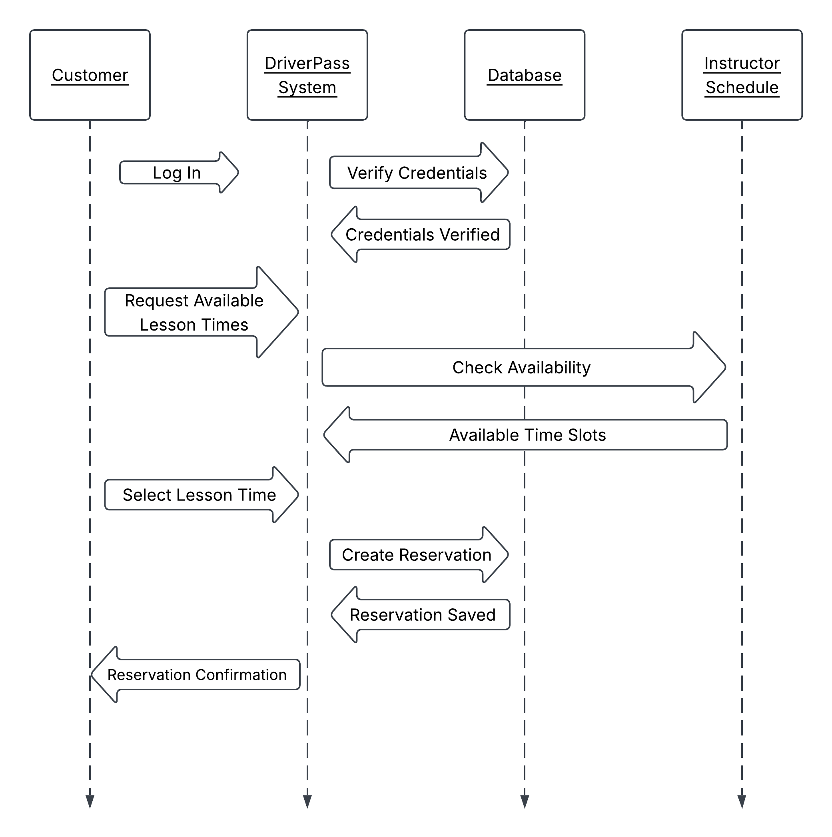
Figure 4. Schedule Lesson Sequence Diagram

UML Class Diagram

The class diagram identifies the primary classes, attributes, and relationships required to support DriverPass business operations.
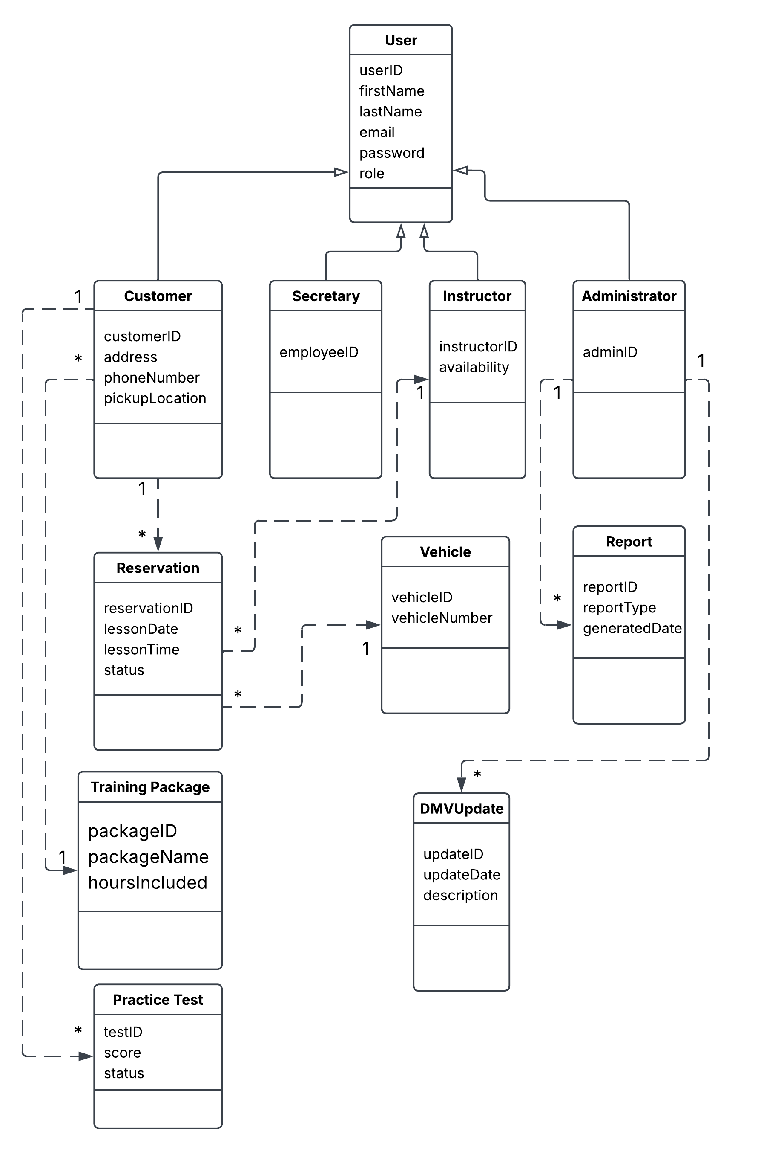

Figure 5. DriverPass Class Diagram

Technical Requirements

The DriverPass system will be a cloud-based web application designed to support online driver education, practice testing, lesson scheduling, customer account management, and administrative operations. The system must provide secure access for customers, instructors, secretaries, administrators, and IT personnel while supporting access from multiple locations and devices. The system must also maintain current DMV content and provide reliable reporting and tracking capabilities.
Hardware Requirements
The DriverPass system will require cloud-hosted application servers, database servers, and backup storage services. Customers and employees will access the system using desktop computers, laptops, tablets, and smartphones connected to the internet. Cloud-based hardware resources were selected because DriverPass requested a web-based solution that minimizes local infrastructure management and allows access from multiple locations.
Hardware Components
- Cloud application server
- Cloud database server
- Backup storage systems
- Desktop computers and laptops
- Tablets and smartphones
- Reliable internet connectivity
Software Requirements
The DriverPass system will operate as a web-based application accessible through modern web browsers such as Microsoft Edge, Google Chrome, Mozilla Firefox, and Safari. A centralized database management system will store customer information, lesson schedules, instructor assignments, training packages, test results, and activity logs. The system will also support password management, progress tracking, and report generation capabilities.
Software Components
- Web-based application
- Relational database management system
- Browser support
- Reporting functionality
- Password management functionality
- Progress tracking tools

Security Requirements
Security is a critical requirement because the system stores customer information, lesson schedules, and payment-related data. The system must require secure authentication before access is granted. Password recovery functionality must be available for users who forget their credentials. Role-based access controls will ensure that users only access information necessary for their job responsibilities. Activity logs will record system changes and appointment modifications to support accountability and auditing requirements. The system will also protect against unauthorized access through account monitoring and security controls.

Security Features
- Secure user authentication
- Password reset capability
- Role-based permissions
- Activity logging
- Audit tracking
- Protection of customer information
- Account monitoring and security controls

Infrastructure Requirements
The DriverPass system will use cloud infrastructure to support scalability, reliability, and simplified maintenance. The infrastructure will include secure network access, automated backup services, disaster recovery capabilities, and integration with DMV information updates. Cloud hosting supports DriverPass's goal of focusing on business operations while minimizing technical maintenance responsibilities. The infrastructure must also support notifications whenever DMV rules, regulations, or testing information are updated.
Infrastructure Components
- Cloud hosting environment
- Web application services
- Database services
- Automated backup services
- Disaster recovery capabilities
- Secure network access
- DMV update integration
- Notification services

Conclusion
The proposed DriverPass system provides a secure, cloud-based platform that supports driver education, lesson scheduling, online testing, customer account management, and reporting functions. The combination of cloud infrastructure, secure access controls, and DMV integration will enable DriverPass to improve customer preparedness while supporting future growth and system enhancements.

